Team Meal Planner

Test Scenarios
People Signup:
Description: Create a new person with name, email, and dietary tags.

Endpoint: POST - http://localhost:8080/people

Test Case P1 – Create person (success)

Request:

{
"name": "Alice",
"email": "alice@example.com",
"dietaryTags": [
"VEGAN"
]
}

Response:

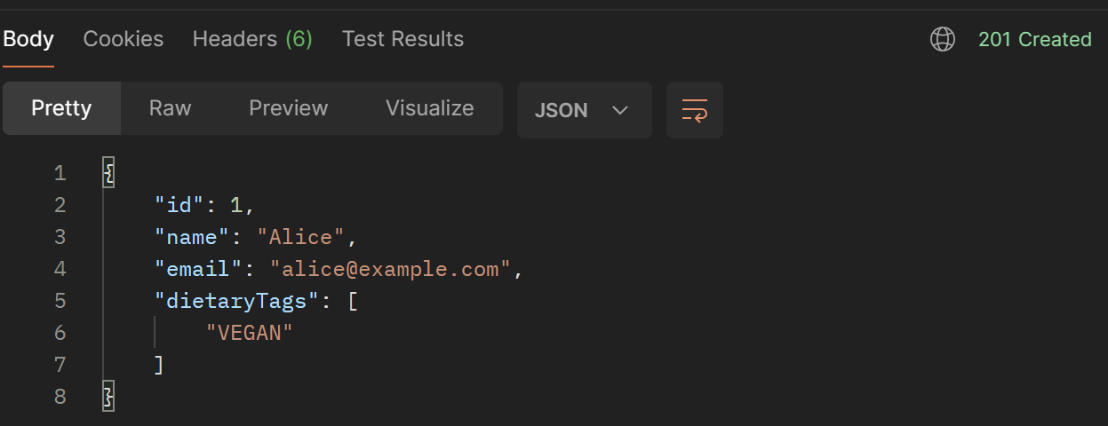

Test Case P2 – Validation error (missing name)
Request:

{
"name": "",
"email": "alice@example.com",
"dietaryTags": [
"VEGAN"
]
}

Response:

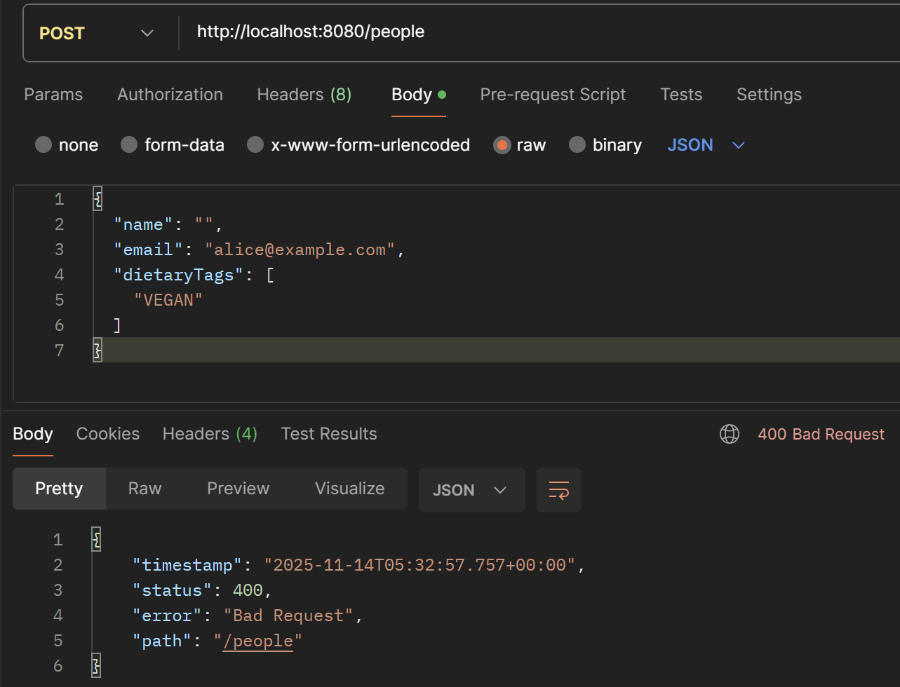

Test Case P3 – Duplicate email (if constrained)

Precondition: person with email alice@example.com already exists.
Request body:

{
"name": "Alice 2",
"email": "alice@example.com",
"dietaryTags": [
"NONE"
]
}

Response: 500 but should get 409.

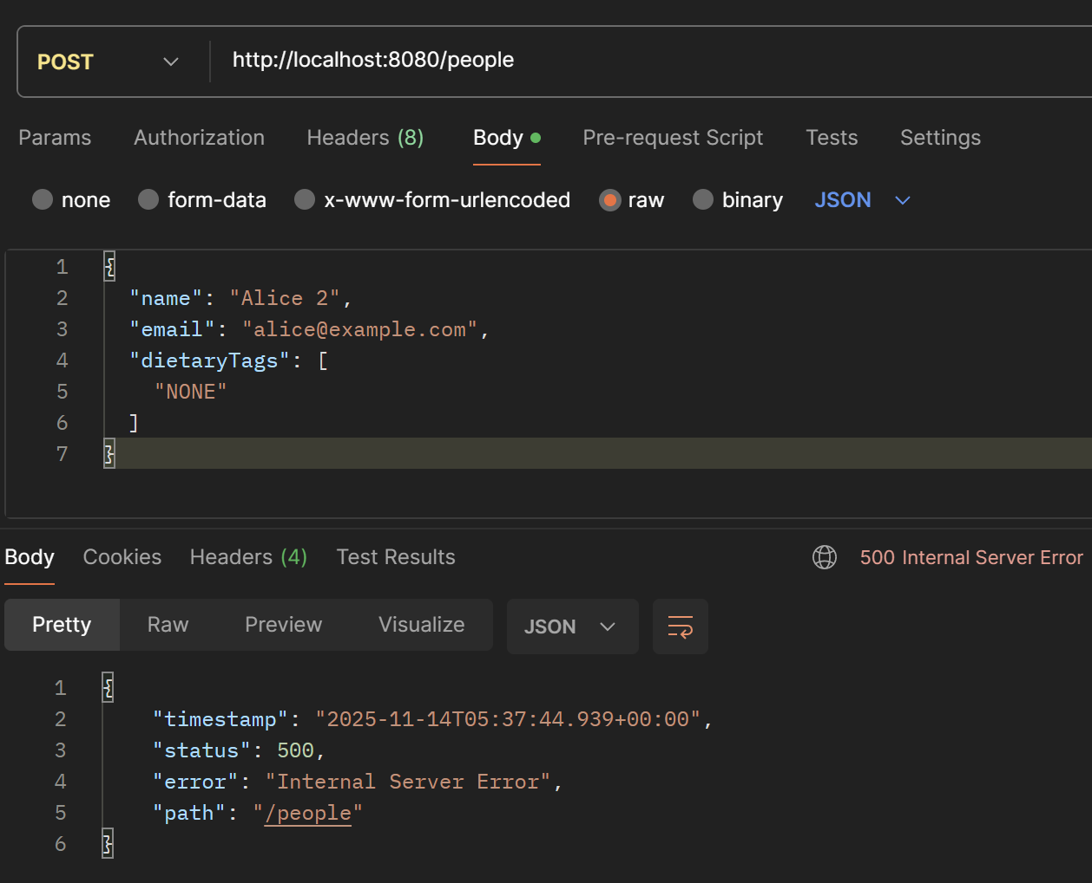

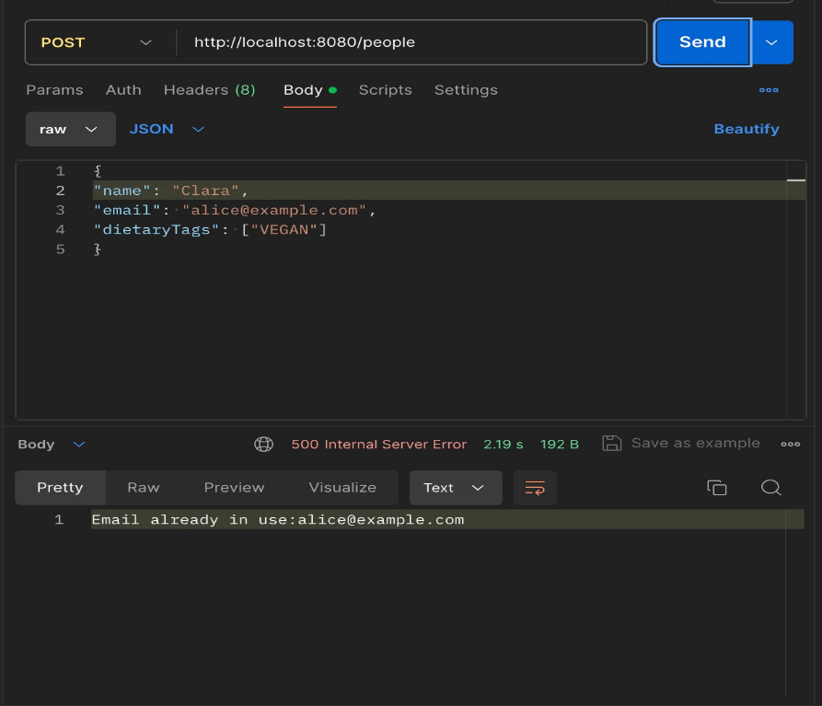

Meals
Endpoint: POST - /meals

Test Case M1 – Create meal (success)
Request:
{
"date": "2025-01-15",
"title": "Team Pizza Lunch",
"cuisine": "ITALIAN",
"tags": [
"VEGETARIAN_FRIENDLY"
],
"maxAttendees": 3
}

Response

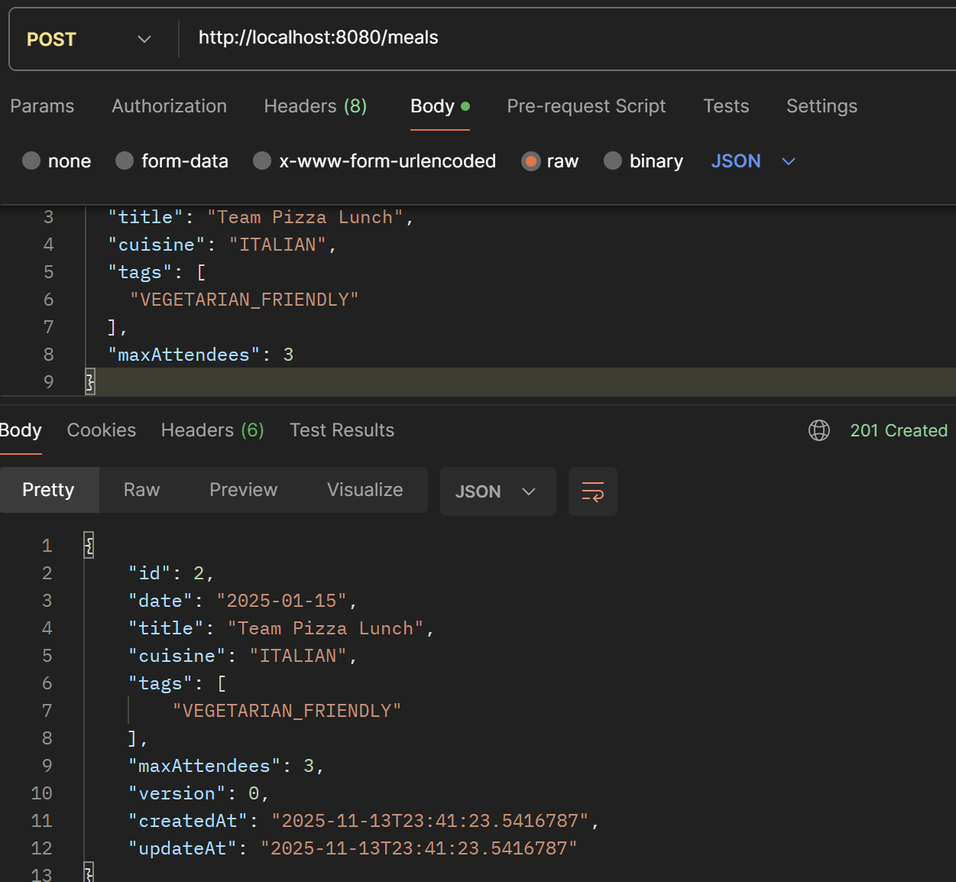

Test Case M2 – Validation error (missing title)
Request:
{
"date": "2025-01-15",
"title": "",
"cuisine": "ITALIAN",
"tags": [
"VEGETARIAN_FRIENDLY"
],
"maxAttendees": 3
}

Response:

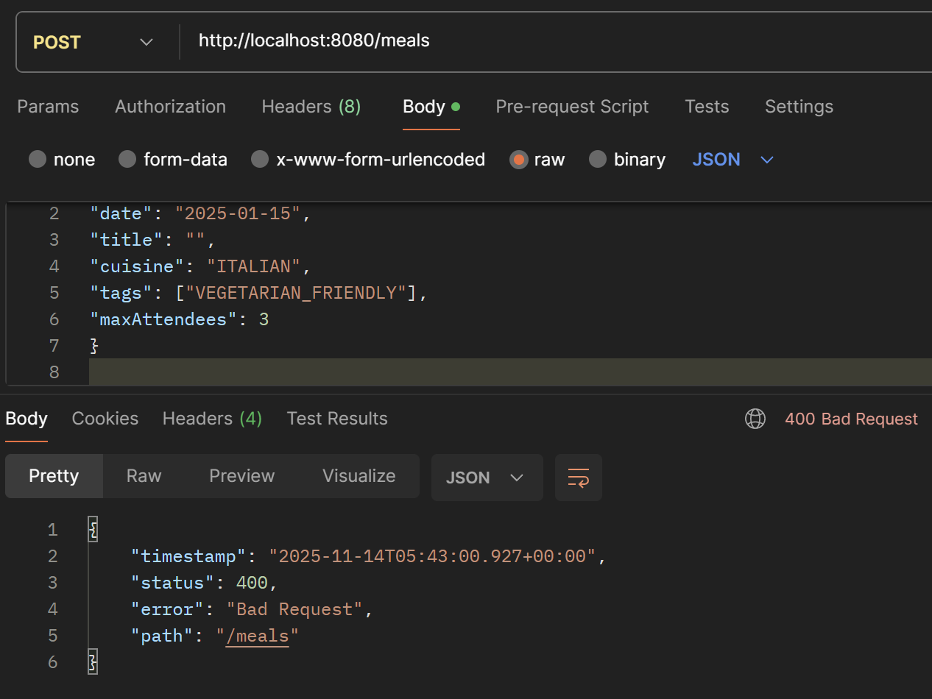

Test Case M3 – Invalid date format
Request:
{
"date": "15-01-2025",
"title": "Bad Date",
"cuisine": "ITALIAN",
"tags": [],
"maxAttendees": 3
}

Response:

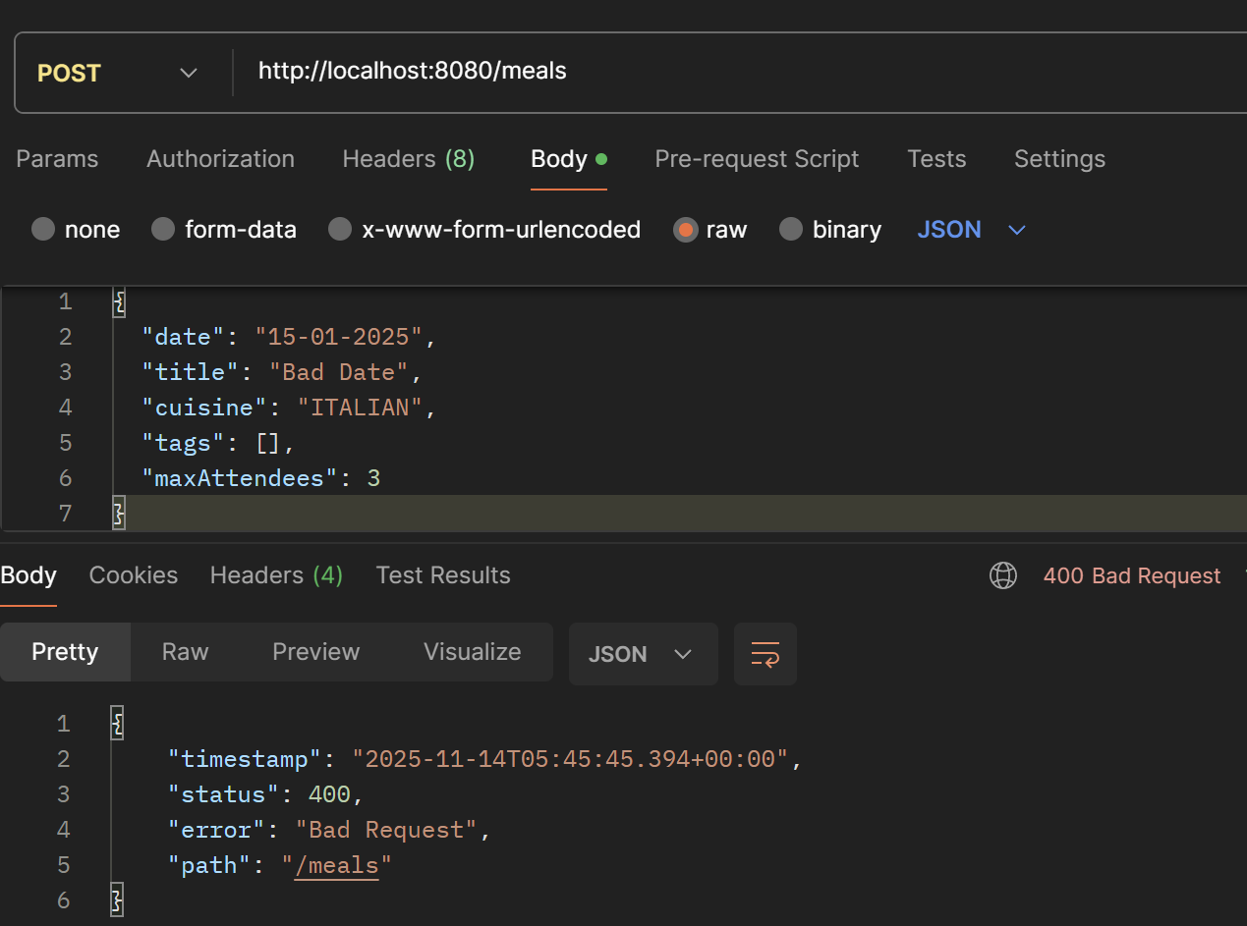

Endpoint: GET - /meals

To get list of all meals

Request: http://localhost:8080/meals/all

Response:

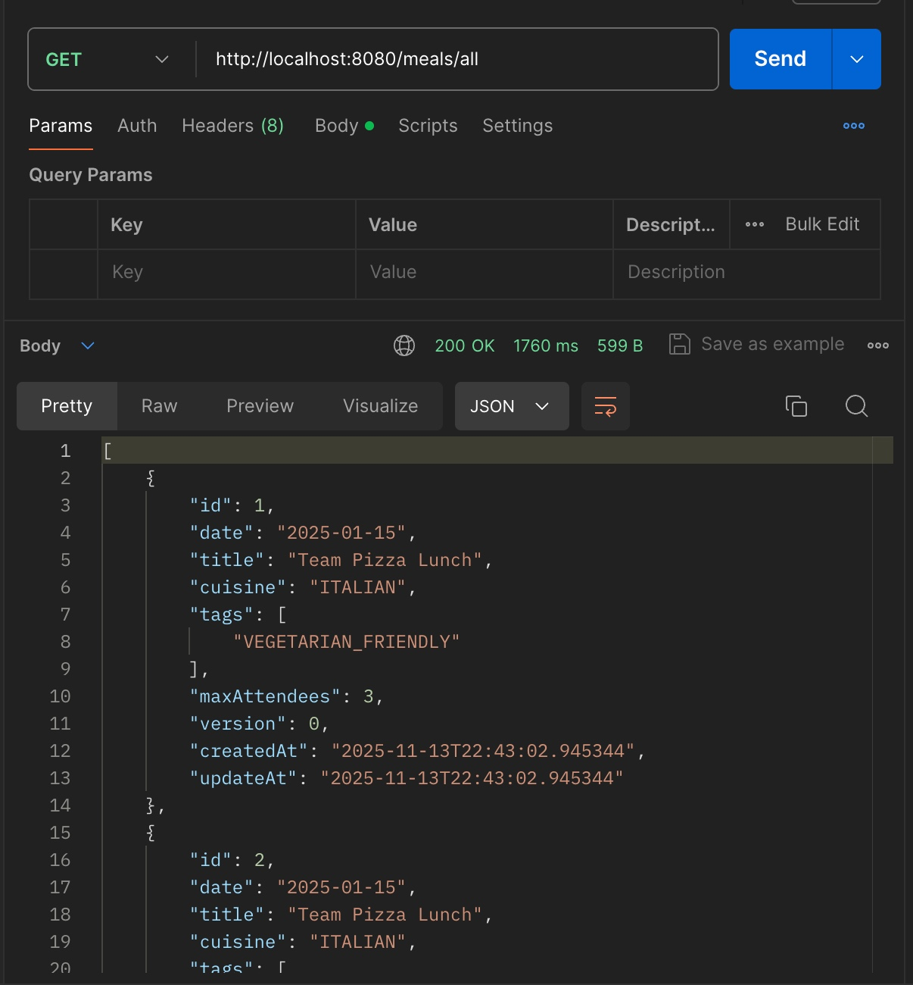

Test Case M5 – Date range filter
Precondition: Create meals on 2025-01-15 and 2025-02-01.
Request: GET /meals?startDate=2025-01-14&endDate=2025-01-16&page=0&size=10

Response:

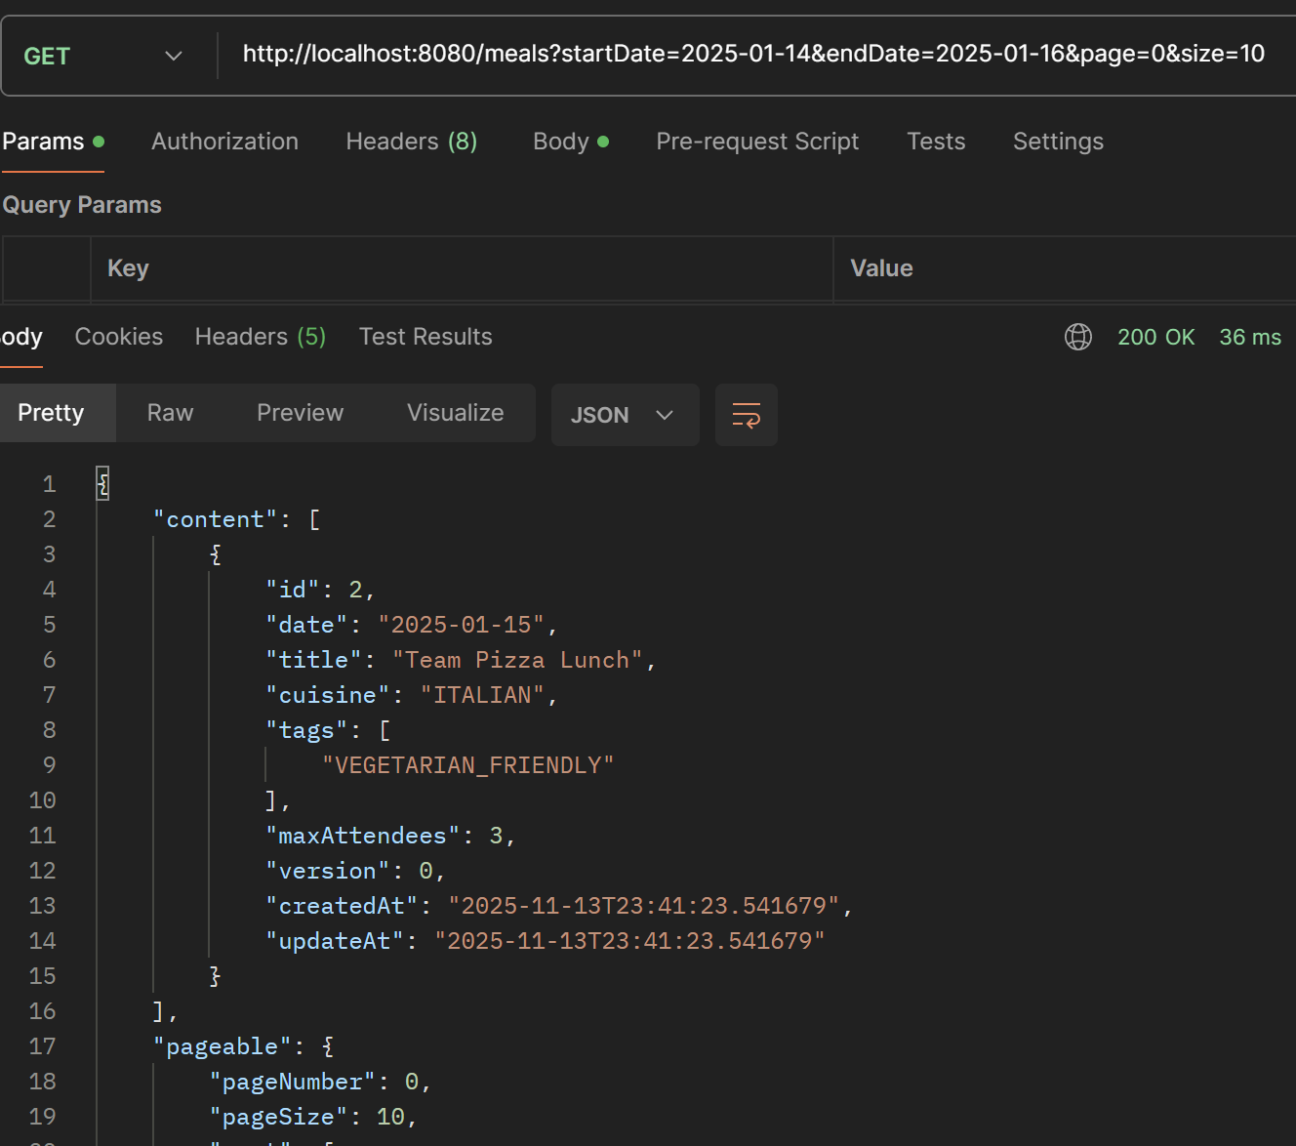
- Only meals whose date is between 2025-01-14 and 2025-01-16 are returned.

Test Case M6 – Cuisine filter
Request: GET //meals?cuisine=ITALIAN&page =0&size=10&startDate=2025-01-14&endDate=2025-01-16

Response:

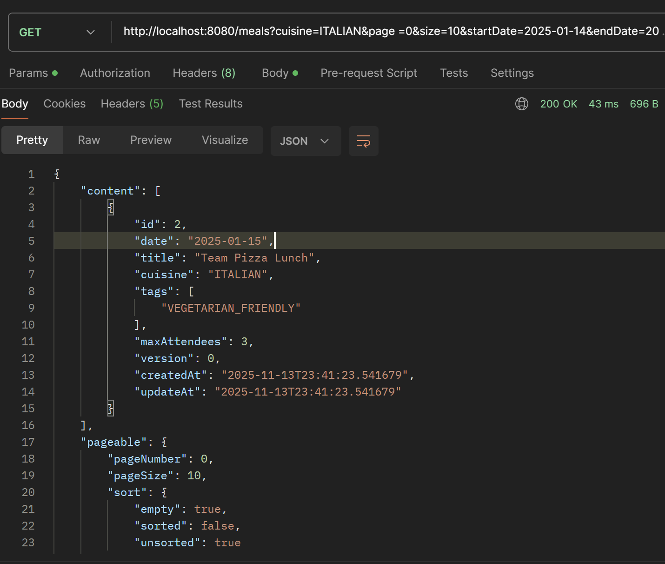

- Only meals with cuisine "ITALIAN" are returned.

Test Case M7 – Tag filter
Request: GET /meals?tag=VEGAN&page=0&size=10
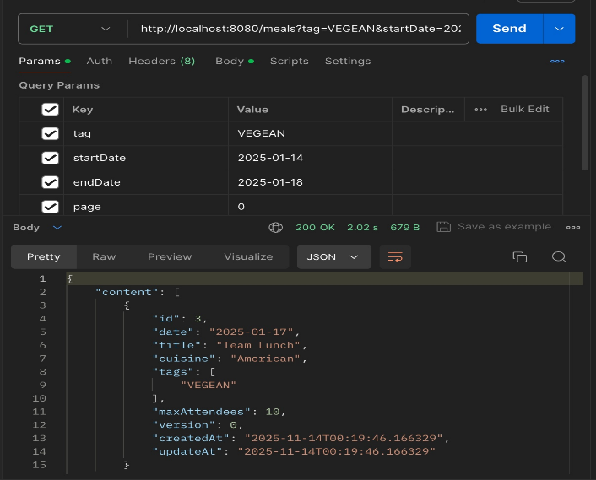
Response: - 200 OK
- Only meals with tags containing "VEGAN" are returned.

GetById : Get a single meal by id. Response should include attendeeCount.

Test Case M8 – Get existing meal
Precondition: meal created, note its id as MEAL_ID.
Request: GET /meals/{id}
Response:
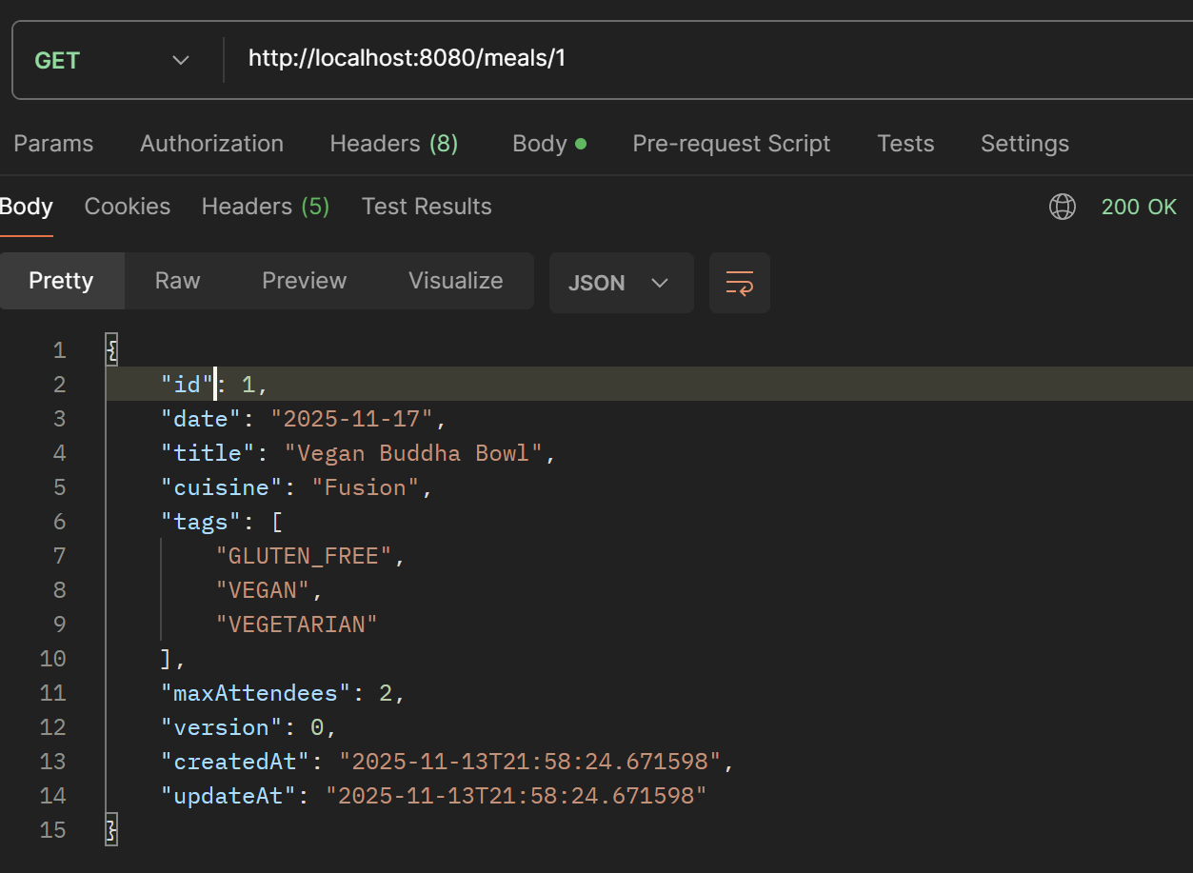

Test Case M9 – Meal not found
Request: GET /meals/999999
Response:

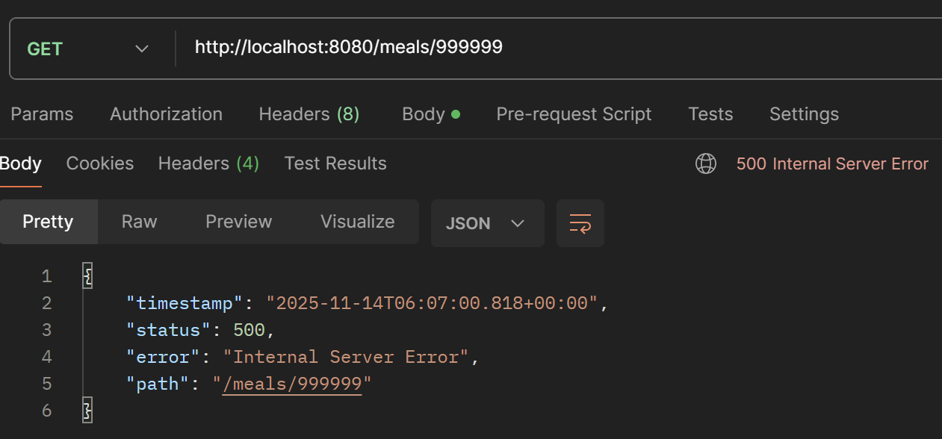

PUT
Request: PUT /meals/{id}
{
"title": "Team Pizza + Pasta Lunch",
"date": "2025-01-15",
"cuisine": "ITALIAN",
"tags": [
"VEGETARIAN_FRIENDLY"
],
"maxAttendees": 4,
"version": 0
}

Response:

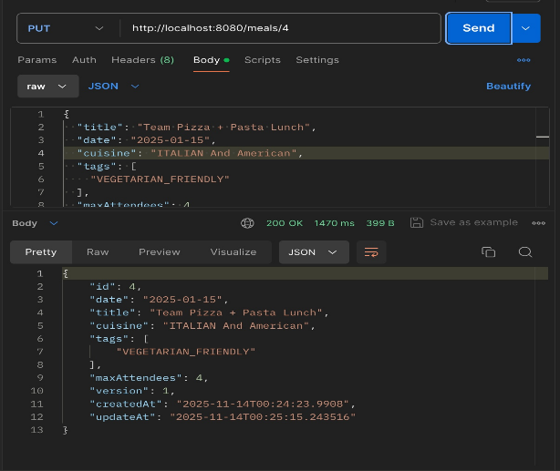
Test Case M11 – Version mismatch (optimistic locking failure)

Request: PUT /meals/MEAL_ID

{
"title": "Team Pizza + Pasta Lunch",
"date": "2025-01-15",
"cuisine": "ITALIAN",
"tags": [
"VEGETARIAN_FRIENDLY"
],
"maxAttendees": 4,
"version": 0
}

Response:

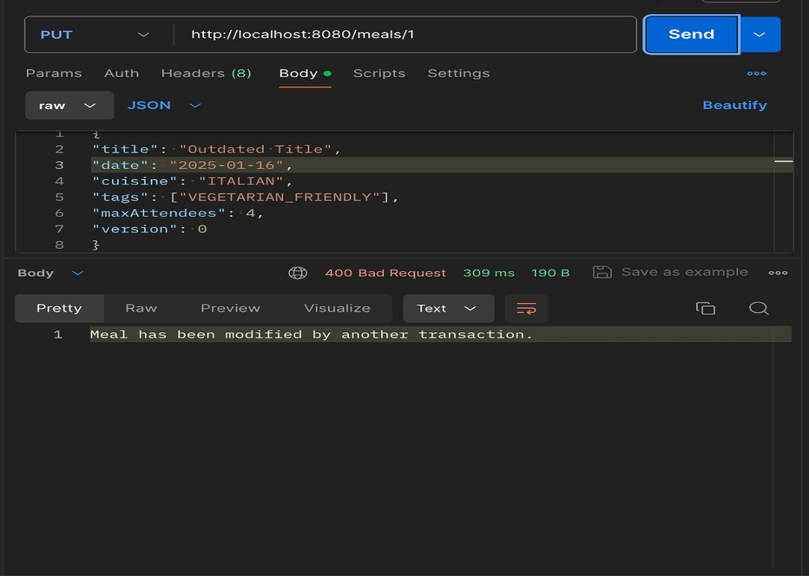

DELETE
Endpoint: DELETE /meals/{id}

Response:

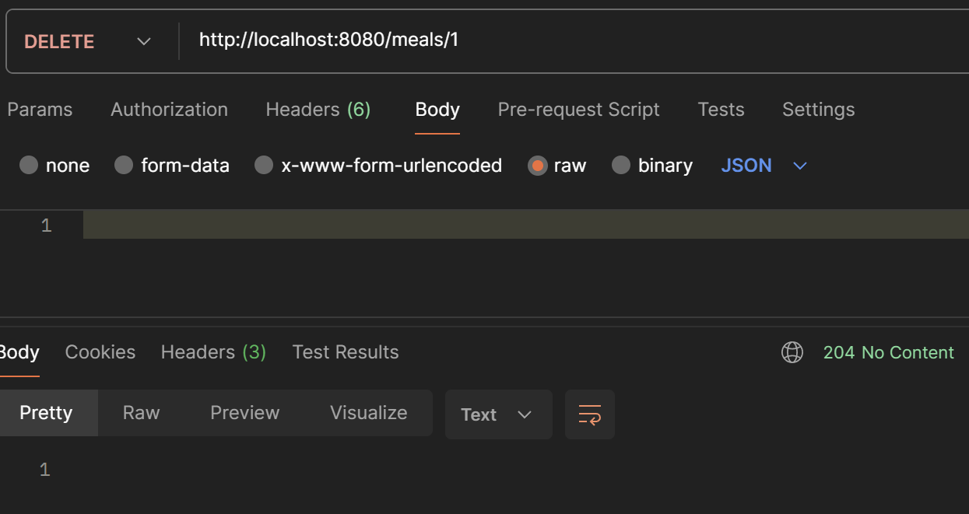

H2 Database Tables Overview:

